# Starting with PHP:

1. Make sure that you have installed the XAMPP and Apache NetBeans, as instructed.
2. Copy the **ex_starts** in the ***xampp/htdocs*** directory.
3. Open the **XAMPP Control Panel** and click **Start** for the Apache and MySQL. You will not be able to run your web applications unless you start the Apache server. You will not need MySQL for all exercises but you will need it for some future exercises. At the end your XAMPP Control Panel should look like this:

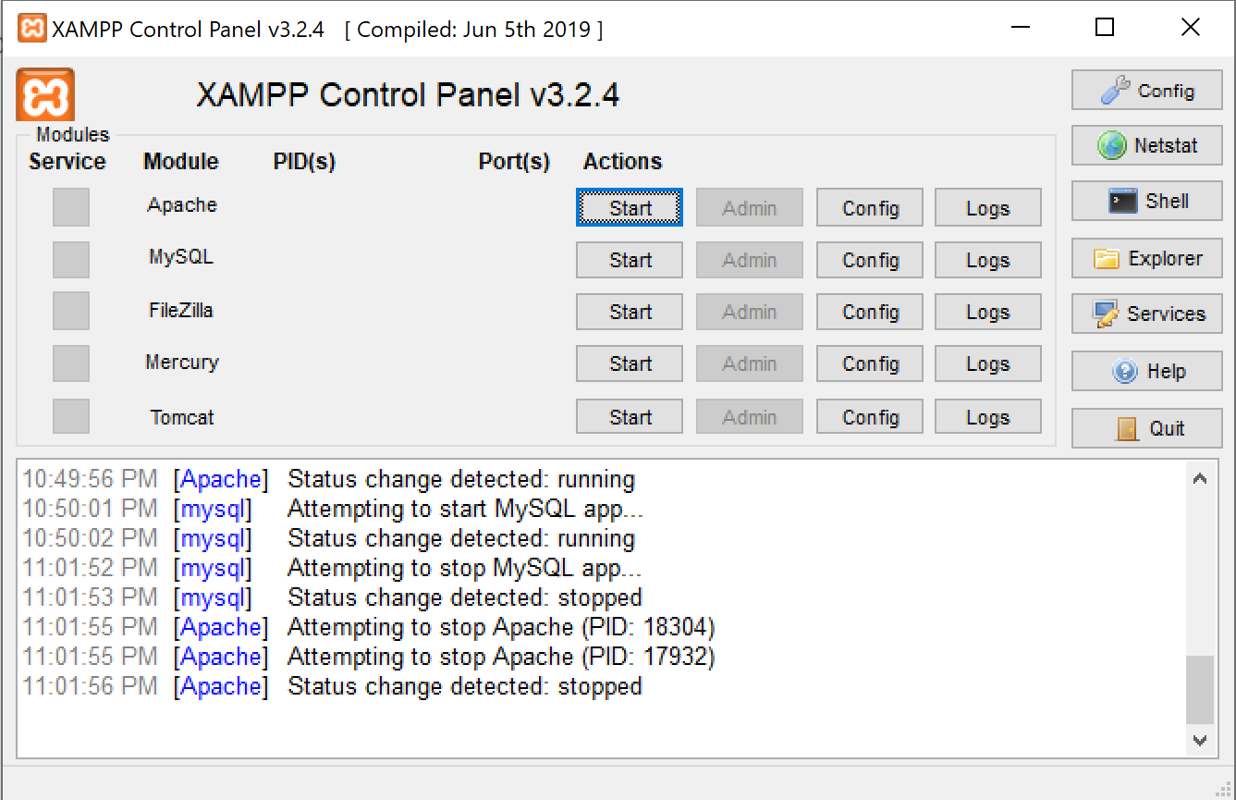

You can minimize the XAMPP Control Panel now but keep the Apache and MySQL started.

1. Open the Apache NetBeans. Now you need to open a project from **ex_starts** folder provided (the one you copied into ***xampp/htdocs*** directory. Click on **File**  and the on **Open Project.**  Navigate to the **ex_starts** and select ch02_ex1 project then click Open Project.
2. Click on the Source Files to display the project files. Click on each project files to examine their content.

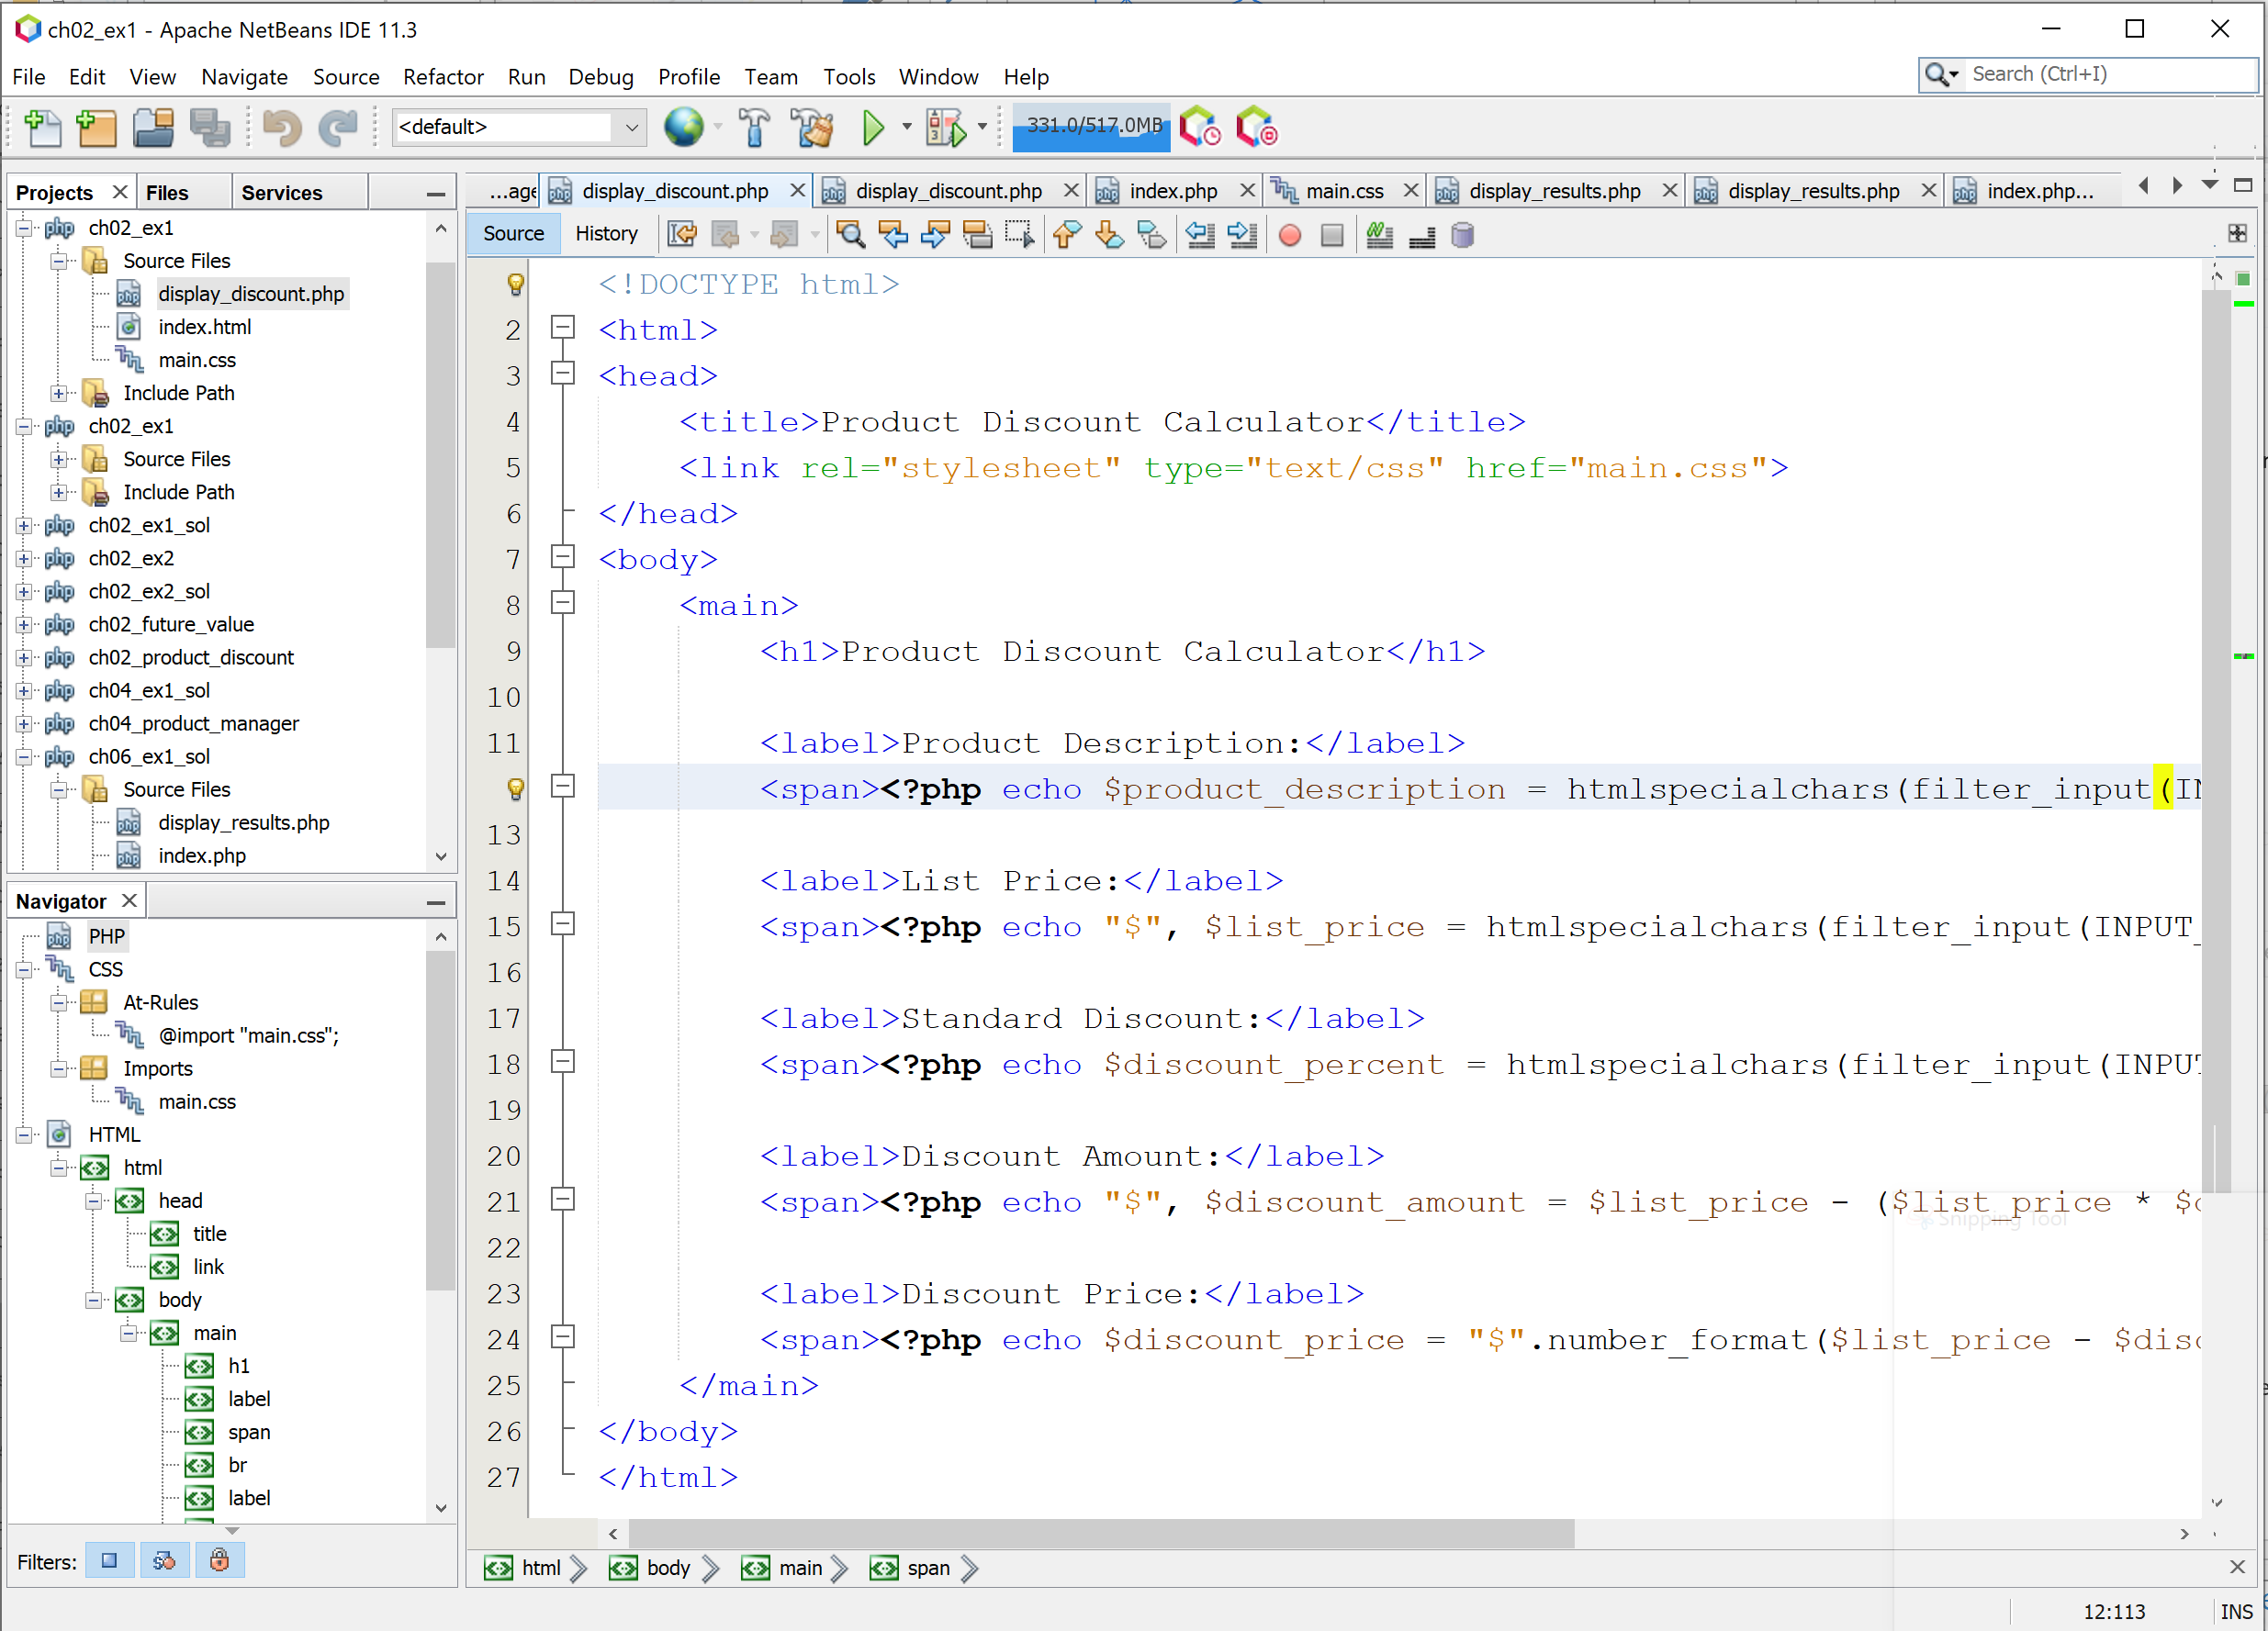

1. Open the Week 1 – Lab Exercises and now you are ready to complete the exercises. Scroll down to **Complete the following exercises** and follow the instructions to complete the exercises.
2. The solution is also provided on the following YouTube link: <https://youtu.be/j7Q9s6svgK4>